Microcontroller Based Food Spoilage and Formalin Detector

Shamimatul Jannat
Department of Computer science and Engineering
East West University
Dhaka, Bangladesh
2016-3-60-026@std.ewubd.edu

Muhammad Farabi Hossain
Department of Computer science and Engineering
East West University
Dhaka, Bangladesh
2016-3-60-051@std.ewubd.edu

BM Jahidul Haque
Department of Computer science and Engineering
East West University
Dhaka, Bangladesh
2017-2-60-133@std.ewubd.edu

Abstract—In this project we designed and develop a detector using microcontroller Arduino Uno that can sense the presence of formaldehyde in different things. This paper presents a complete design, implementation and testing of formalin detection kit based on a microcontroller. We develop a food quality detecting technique, where the sensors will be associated along the Arduino. It will send client to information regarding freshness through android portable. The objective of the study was to design and develop a system that can detect formaldehyde concentration and food spoilage. This paper is employed to solve the food spoilage problem and formalin detection with the sensor assistance to identify the spoilage by continuous sensing. Which will saves time, and save health from the effect of formalin by detecting that, along with that can give the alert or decaying of food.

Keywords— Arduino UNO, Food quality, Gas sensor, sensor, Formaldehyde.

introduction
Food is an important thing for our livelihood, it is one of our basic needs. Eating safe and unadulterated food is essential and inevitable for us but nowadays it is often seen that food is being adulterated, formalin is being added to the food to protect the food from decay. Which is extremely harmful to health. Occupants inhaling contaminated air, the major exposure risks associated with formaldehyde come from. It causes asthma attack, nausea, watery and/or burning eyes, difficulty breathing, headaches, respiratory irritation, sensitization. It also has been shown to cause cancer in animals and according to the Department of Health and Human Services (DHHS), formaldehyde may “reasonably be anticipated to be a carcinogen”. This substance should be avoided [1]. The liquid form of formaldehyde (35-40% aqueous solution) known as formalin is widely used as a precursor in chemical industries due to its high reactivity and relatively low cost and as a preservative in medical laboratories[2]. Illegal use of formaldehyde is being increased day by day. As it is dangerous to health there should be something which can stopped illegal usages of it. Along with that if people can detect that whether the things they’re are using there is formalin or not that will be great. For that formalin detector kit was invented. The food quality must be monitored and also should be prevented from decaying and routing the atmospheric factors such as darkness, humidity and temperature. Therefore, by deploying quality monitoring devices at food stores the wastage can be minimized. To detect formalin, formaldehyde detector is used. It is a low cost gas detector that was developed by the proponents to detect any presence of formaldehyde in the environment. Purpose of it was to detect the user of the formaldehyde concentration in parts per million (ppm) as unit of measurement for formaldehyde gas concentration. There are various factors that leads to food poisoning, like humidity and temperature changes. So that the monitoring system which is capable of measuring the humidity and temperature difference during the food storage and transportation is of prime importance. In this project we will made a device which can detect the formalin by using the gas sensor.

Related works
Although there is so many works related formalin detection and spoilage of the food IOT based. These works shows the result after implementing the input and do the test on their maiden device. Day by day usage of it is increasing. Most amount of people are using these kits to make their life easier.
Here Volatile organic compound gas sensor used which detect the formaldehyde presence in suitable products. Their maiden kit successfully works on their collected sample products and solutions prepared in laboratory. It gives the result on their collected samples like Green Apple, Banana and Guava shows the level of HCHO is Null. And others samples like Red Apple’s HCHO level is 0.22, HCHO level of orange is 0.19, Berry’s 0.28, Rui fish = 0.31, Apple with 40% HCHO is .33 and Apple with 20% HCHO is .12. The concentration of formalin shown in ppm (parts per million). In this prototype they used an android application with the device to save real time data, so that the user can be sent message with the location [3]. Here in another one it shows that there development of electronic reader is based on SnCl2 sensor which is capable to detect separate concentration of formaldehyde gas decoder from variation in voltage level, which is in microprocessor. After that it measured voltage which produces output signal on PIC kit. PIC kit stores form of LED light which shows three conditions which are Reject, Quarantine and low, then LCD first show the condition, after that it shows the concentration percentage in chamber of formaldehyde gas [4].

Proposed Algorithm

MQ2
DHT 11
Food
Moisture Sensor

Arduino

Power Supply
16X2 LCD Screen
HCHO Gas Sensor
ESP8266 Wi-Fi

Fig-1: Block Diagram of Arduino based food spoilage and formalin detector

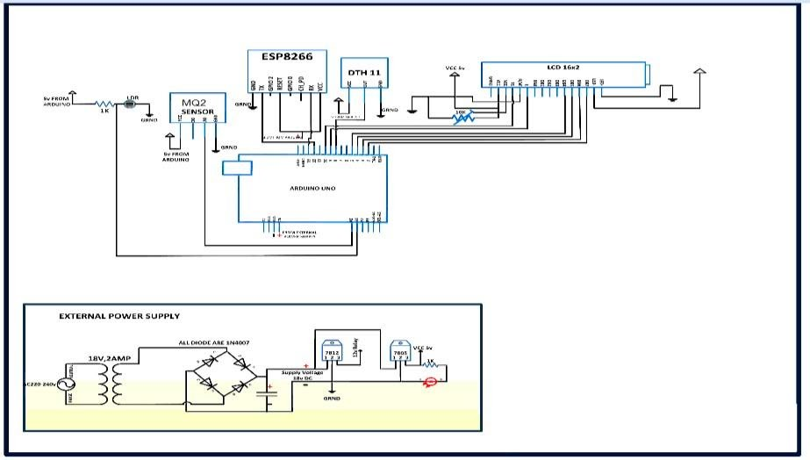

Fig. 2. Circuit Diagram of Arduino based food spoilage and formalin detector
The main brain of this project is the Arduino, but in-order to sense gas, temperature, humidity, formalin we have used different types of sensor module

Methedology
Aim of this device is biosensor, and waste of nourishment separation will be done with electronic. In this sensor different parameters of sustenance as like pH, dampness, and ethanol level will be used. This system will contain Bluetooth, Microcontroller Arduino, electrical and biosensor like dampness sensor, gas sensor, pH sensor. The system is unmistakable prototyping as it is based on Arduino UNO. Bluetooth module will be used for clients, clients will receive information related freshness through portable Android. It will show the message “Perfect for utilizing” or “Not perfect for utilizing” depend on the freshness of the sustenance. From any place, any device with the help of internet ecological component can be observed. So EP8266 Wi-Fi modem is interfaced with the Arduino as it is associated o the web. Nourishment is very important thing for this project. So it should be placed in the sensing range area. It will be compare with comparing value which are already into the microcontroller, after sensing of different sensor. Important elements of this systems which are temperature, moisture and liquor content will be continuously monitored by the system. Different sensor showed in the proposed model like MQ2 which is used for liquor content, DHT-11 used for temperature and moistness will be linked with Arduino UNO board. The Grove-HCHO Sensor is a semiconductor VOC gas sensor. Its conductivity changes with the concentration of VOC gas in air. Through the circuit, the conductivity can be converted to output signal that corresponding to the gas concentration. This sensor can detect the gas whose concentration is up to 1ppm and more. Besides formaldehyde, it is also suitable for detecting benzene, toluene and other volatile components.

Experiment and result
When the things are going to be decay or before that by observing odor, Arduino based gas sensor were able to sense gases and will provide the necessary information to the client. As there is 3 gases, so spoilage food will be compared with the level of emission. That Arduino gas sensor is highly sensitive so, even in low amount of emission of methane and ammonia can be detected. And that is generated by decaying food. The experiment will on all types of food. Everything’s give a satisfying result but fruits produce better result if we compare it with others. Some food provide much lower value, like Milk. There is a HCHO sensor. It is used for detecting formalin. So it’s placed near food sample under investigation and concentration of formalin. Sensor data is wrapped as proper strings which are passing to LCD for display and the Arduino collects all the data from sensor to convert the value to string. The levels of the gas emissions were very high (>20-fold) when visible signs of decay started to appear.

COMPENENTS REQUIRED:
1. Arduino UNO
2. ESP-8266 Wi-Fi module
3. 16*2 LCD Display
4. DHT-11 Sensor
5. Light Sensor
6. Humidity sensor
7. HCHO Gas Sensor
8. Connecting Wire
9. Small Bread broad

Arduino Uno:
Arduino UNO is a microcontroller board. It has 14 digital input/output pins (of which 6 can be used as PWM outputs), 6 analog inputs, a 16 MHz quartz crystal, a USB connection, a power jack, an ICSP header and a reset button. It contains everything needed to support the microcontroller; simply connect it to a computer with a USB cable or power it with an AC-to-DC adapter or battery to get started.

Future work

Although we did the whole project with the help of simulation, we did not implement it in hardware as pandemic situation is going on. So we will implement the project in hardware in future. When we will implement it in hardware we will add some more features like by making android applications, detector can be controlled from mobile and a dataset can record all data and send it to user’s email.

conclusion
Adding formalin in food is getting increasing day by day. Detecting that is very important, as it is harmful to health, so to reduce and avoid illness we use biosensors and electrical sensors to determine the freshness of household food items like dairy, fruits, and meat to expend the device for more items by adding new sensors and by using existing sensors. Hope this device will bring more efficiency and effectiveness in formaldehyde sensing operations. And will save people from dangerous effect of formalin.

References
[1] “Formaldehyde Facts, Uses, Health Related Issues.” .
[2] H. Yousefi, M. M. Ali, H. M. Su, C. D. M. Filipe, and T. F. Didar, “Sentinel Wraps: Real-Time Monitoring of Food Contamination by Printing DNAzyme Probes on Food Packaging,” ACS Nano, vol. 12, no. 4, pp. 3287–3294, 2018, doi: 10.1021/acsnano.7b08010.
[3] A. Kamal, N. Nusrat, and N. S. Dola, “Design and Development of A Formalin Detection System Using IoT,” vol. 10, no. 9, pp. 344–348, 2019.
[4] U. Hashim et al., “Development of electronic reader for formaldehyde detection sensor,” Proc. - 2015 2nd Int. Conf. Biomed. Eng. ICoBE 2015, no. March, pp. 30–31, 2015, doi: 10.1109/ICoBE.2015.7235899.

